Create a nojs Save SharePoint list form

1. Create a SharePoint list “SPFxEvents” with below columns <https://jpower4mvp.sharepoint.com/sites/SPFxTraining/Lists/SPFxEvents/AllItems.aspx>
   1. Title – already available – rename to Event Name
   2. Event Date – date
   3. Organizer – people & group
   4. Event Details – Multiline
   5. Event Type - Choice

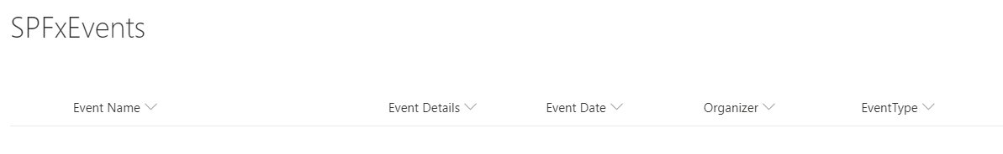

1. Create a Spfx webpart
   1. Open Command Prompt
   2. Create a folder nojsSubmitForm
   3. Navigate to nojsSubmitForm folder

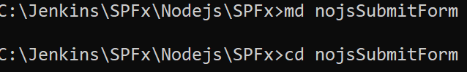

* 1. Create a new web part by running the Yeoman SharePoint Generator
  2. yo @microsoft/sharepoint
  3. When prompt fill all informations

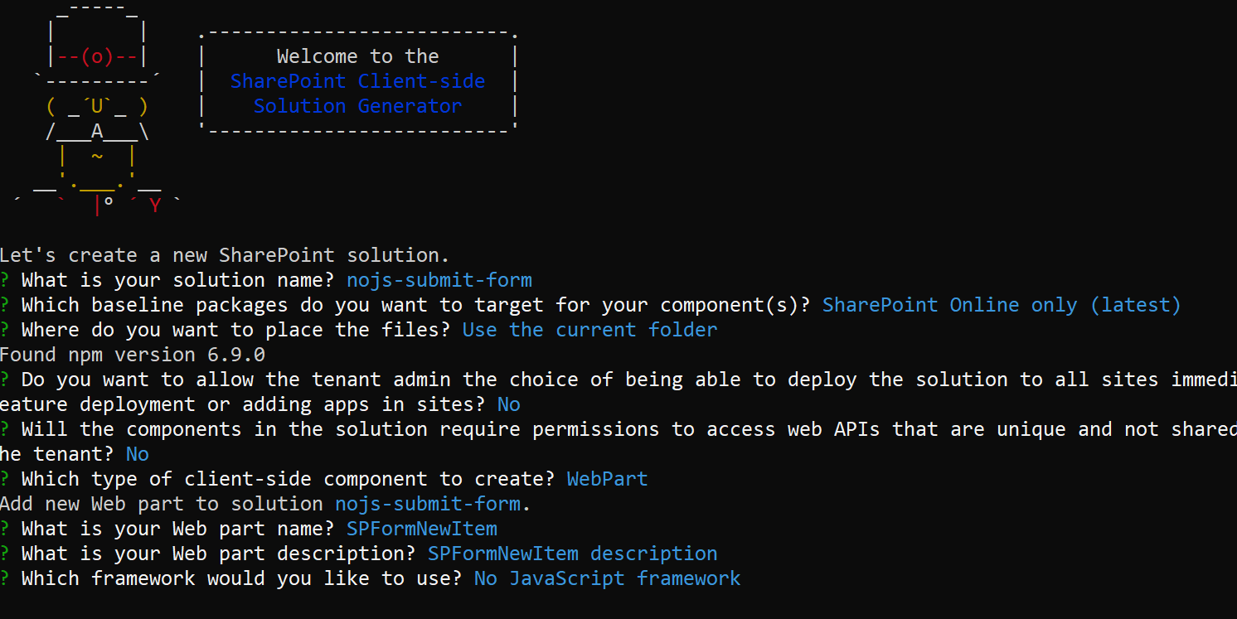

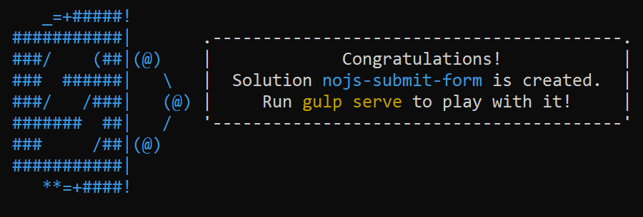

Open the project in visual studio code using > code .

We need to include Text box, People picker, Date control, drop down

After finished creating the WebPart solution using Yo generator install the bootstrap and font awesome using the below

npm install jquery --save

npm install @types/jquery --save-dev

npm install bootstrap@4 --save

npm install @types/bootstrap@4 --save-dev

Add external references to the config.json file  
Locate the config.json file under the config folder and add the below entry to the file

**"externals": {**

"jquery": {

"path": "node_modules/jquery/dist/jquery.min.js",

"globalName": "jQuery"

},

"bootstrap": {

"path": "node_modules/bootstrap/dist/js/bootstrap.min.js",

"globalName": "bootstrap"

}

**}**